Adityaprava Sen

CSE 2nd Year

Roll-56

Assignment on Functions: Outputs

Q1-Q4:

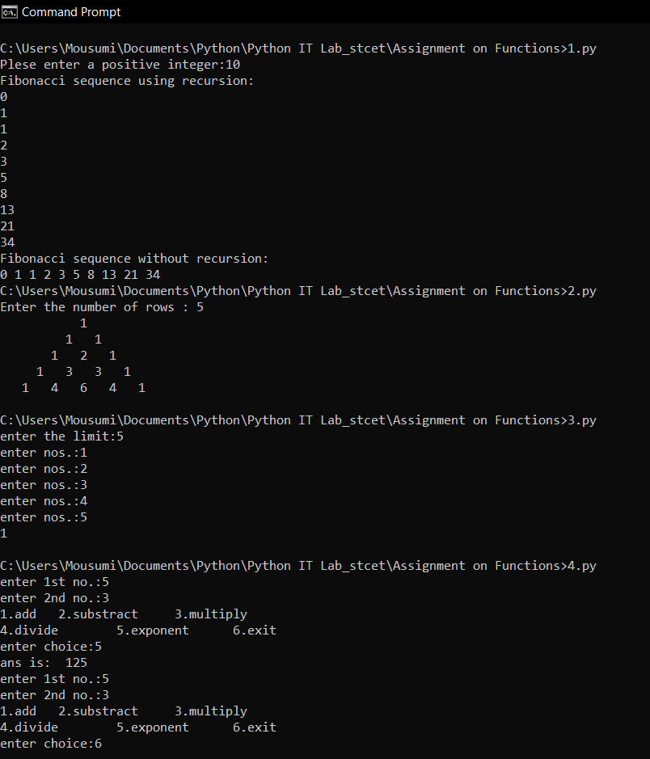

Q5-Q9:

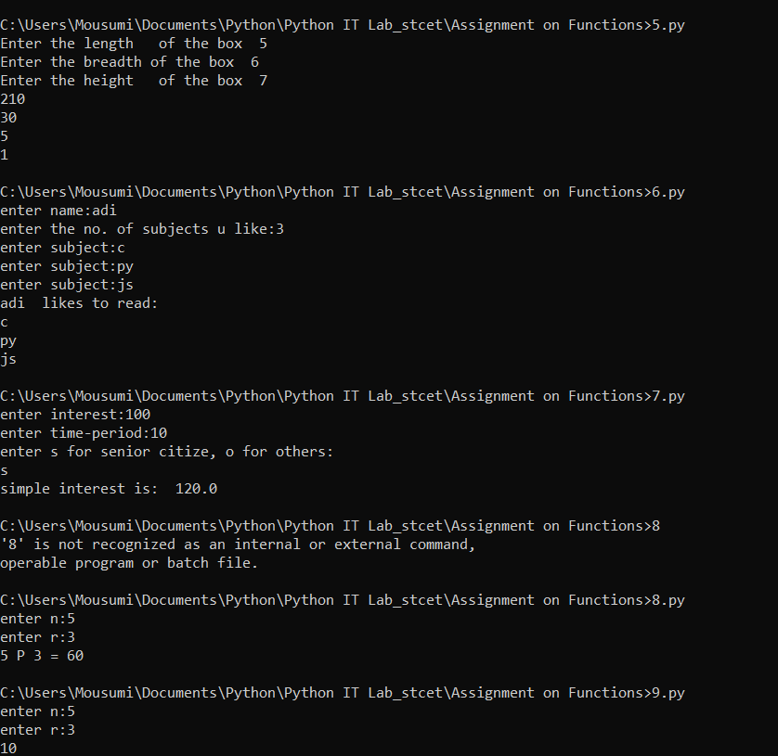

Q10-Q11:

